3.4 Technology Stack

Layer | Technology
UI | Salesforce Lightning, Lightning Web Components (LWC)
Logic | Salesforce Flows, Apex
Database | Salesforce Custom Objects (Policy c, Claim c), Contact, User
Automation | Record-Triggered Flows, Validation Rules, Approval Processes
Processing | Apex Premium Calculator, Apex Controllers
Data Configuration | Record Types, Field Sets, Custom Fields
Security | Permission Sets, State-Based Sharing Rules
Reporting | Salesforce Reports & Dashboards
Testing | Apex Test Classes

PROJECT DESIGN PHASE

Problem–Solution Fit
Salesforce is a strong fit for the Multi-Line Insurance Policy and Claims Management System because it directly addresses the project's key challenges through configurable automation, flexible data management, secure access, and real-time visibility. The solution combines Screen Flows, Record Types, Field Sets, Apex, Record-Triggered Flows, Approval Processes, and LWC to support policy quoting, premium calculation, claim routing, claim approval, and adjuster operations.
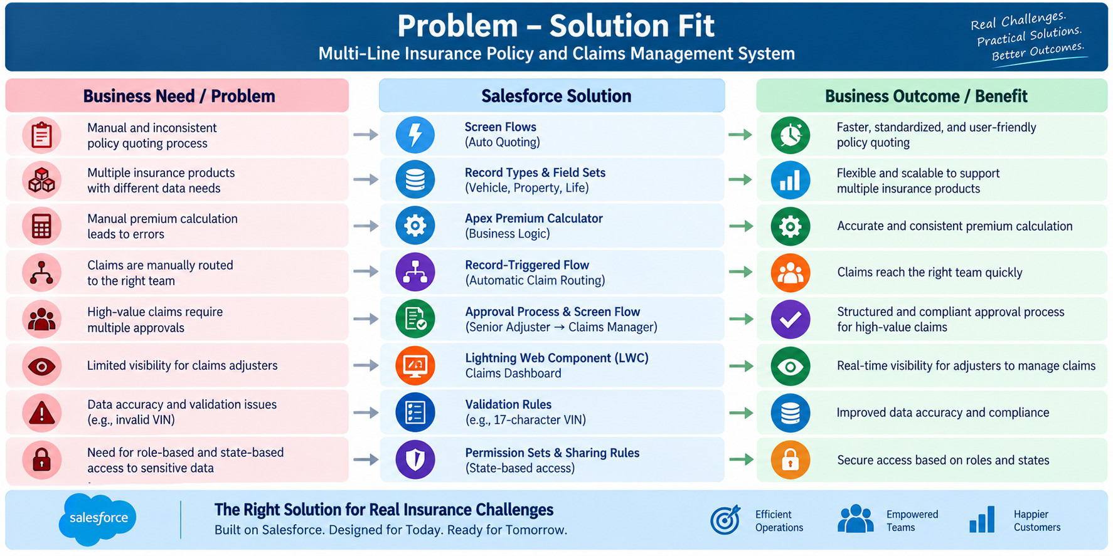

Proposed Solution
Functional Requirements

Parameter | Description
Problem | Manual and inconsistent policy quoting, issuance, and claims handling
Solution | Salesforce CRM-based Insurance Policy & Claims Management System
Innovation | Automated quoting, premium calculation, claim routing, and high-value claim approval
Impact | Faster policy processing, efficient claim handling, and improved customer service
Business Model | Centralized management of Vehicle, Property, and Life Insurance
Scalability | Flexible data model supporting multiple insurance products and future expansion

Visibility | Centralized Customer, Policy, and Claim information with Claims Dashboard
Security | Role-based and state-based access using Permission Sets and Sharing Rules
The proposed solution is aligned with the project's documented objective of creating a single Salesforce platform to standardize policy processes, automate claims, and provide a 360-degree view of Customer, Policy, and Claim data.

Solution Architecture
The Multi-Line Insurance Policy and Claims Management System uses a layered Salesforce architecture to manage policy quoting, premium calculation, claims processing, approvals, security, and reporting.

Key Architecture Components

Layer | Project Implementation
User Layer | Insurance Agents, Claims Adjusters, Claims Managers
UI Layer | Salesforce Lightning, Screen Flows, LWC
Automation Layer | Record-Triggered Flows, Approval Processes, Validation Rules
Business Logic | Apex Premium Calculator and Claims Controller
Data Layer | Policy and Claim custom objects with Vehicle, Property, and Life Record Types
Security Layer | Permission Sets and state-based Sharing Rules
Reporting Layer | Claims Dashboard, Reports and Salesforce Dashboards

